# CS 242 Project Manuel Test Plan

## Create

Go to the website:

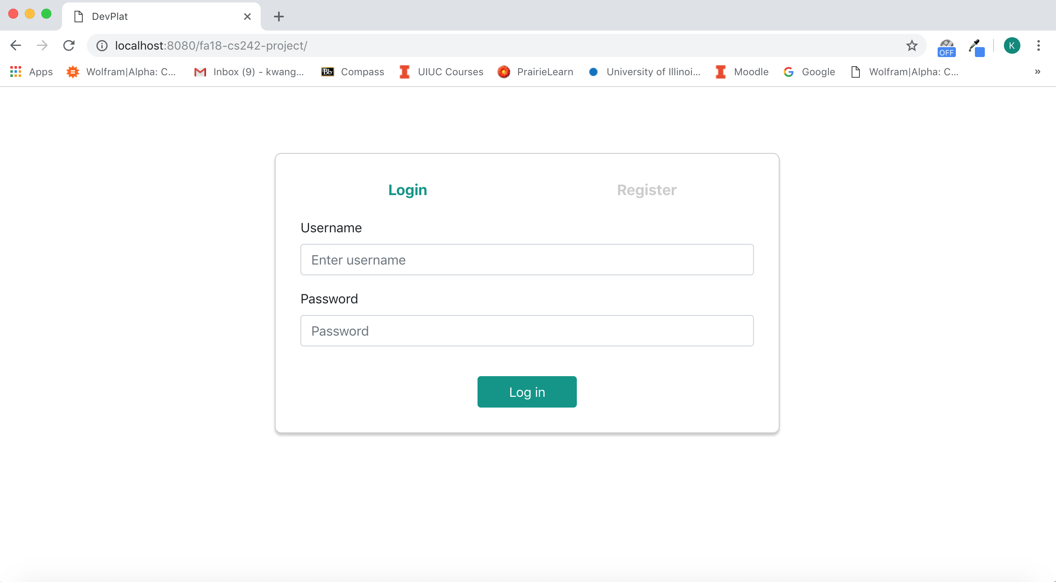

Use “usernumber1” and “123456” as username and password to log in:

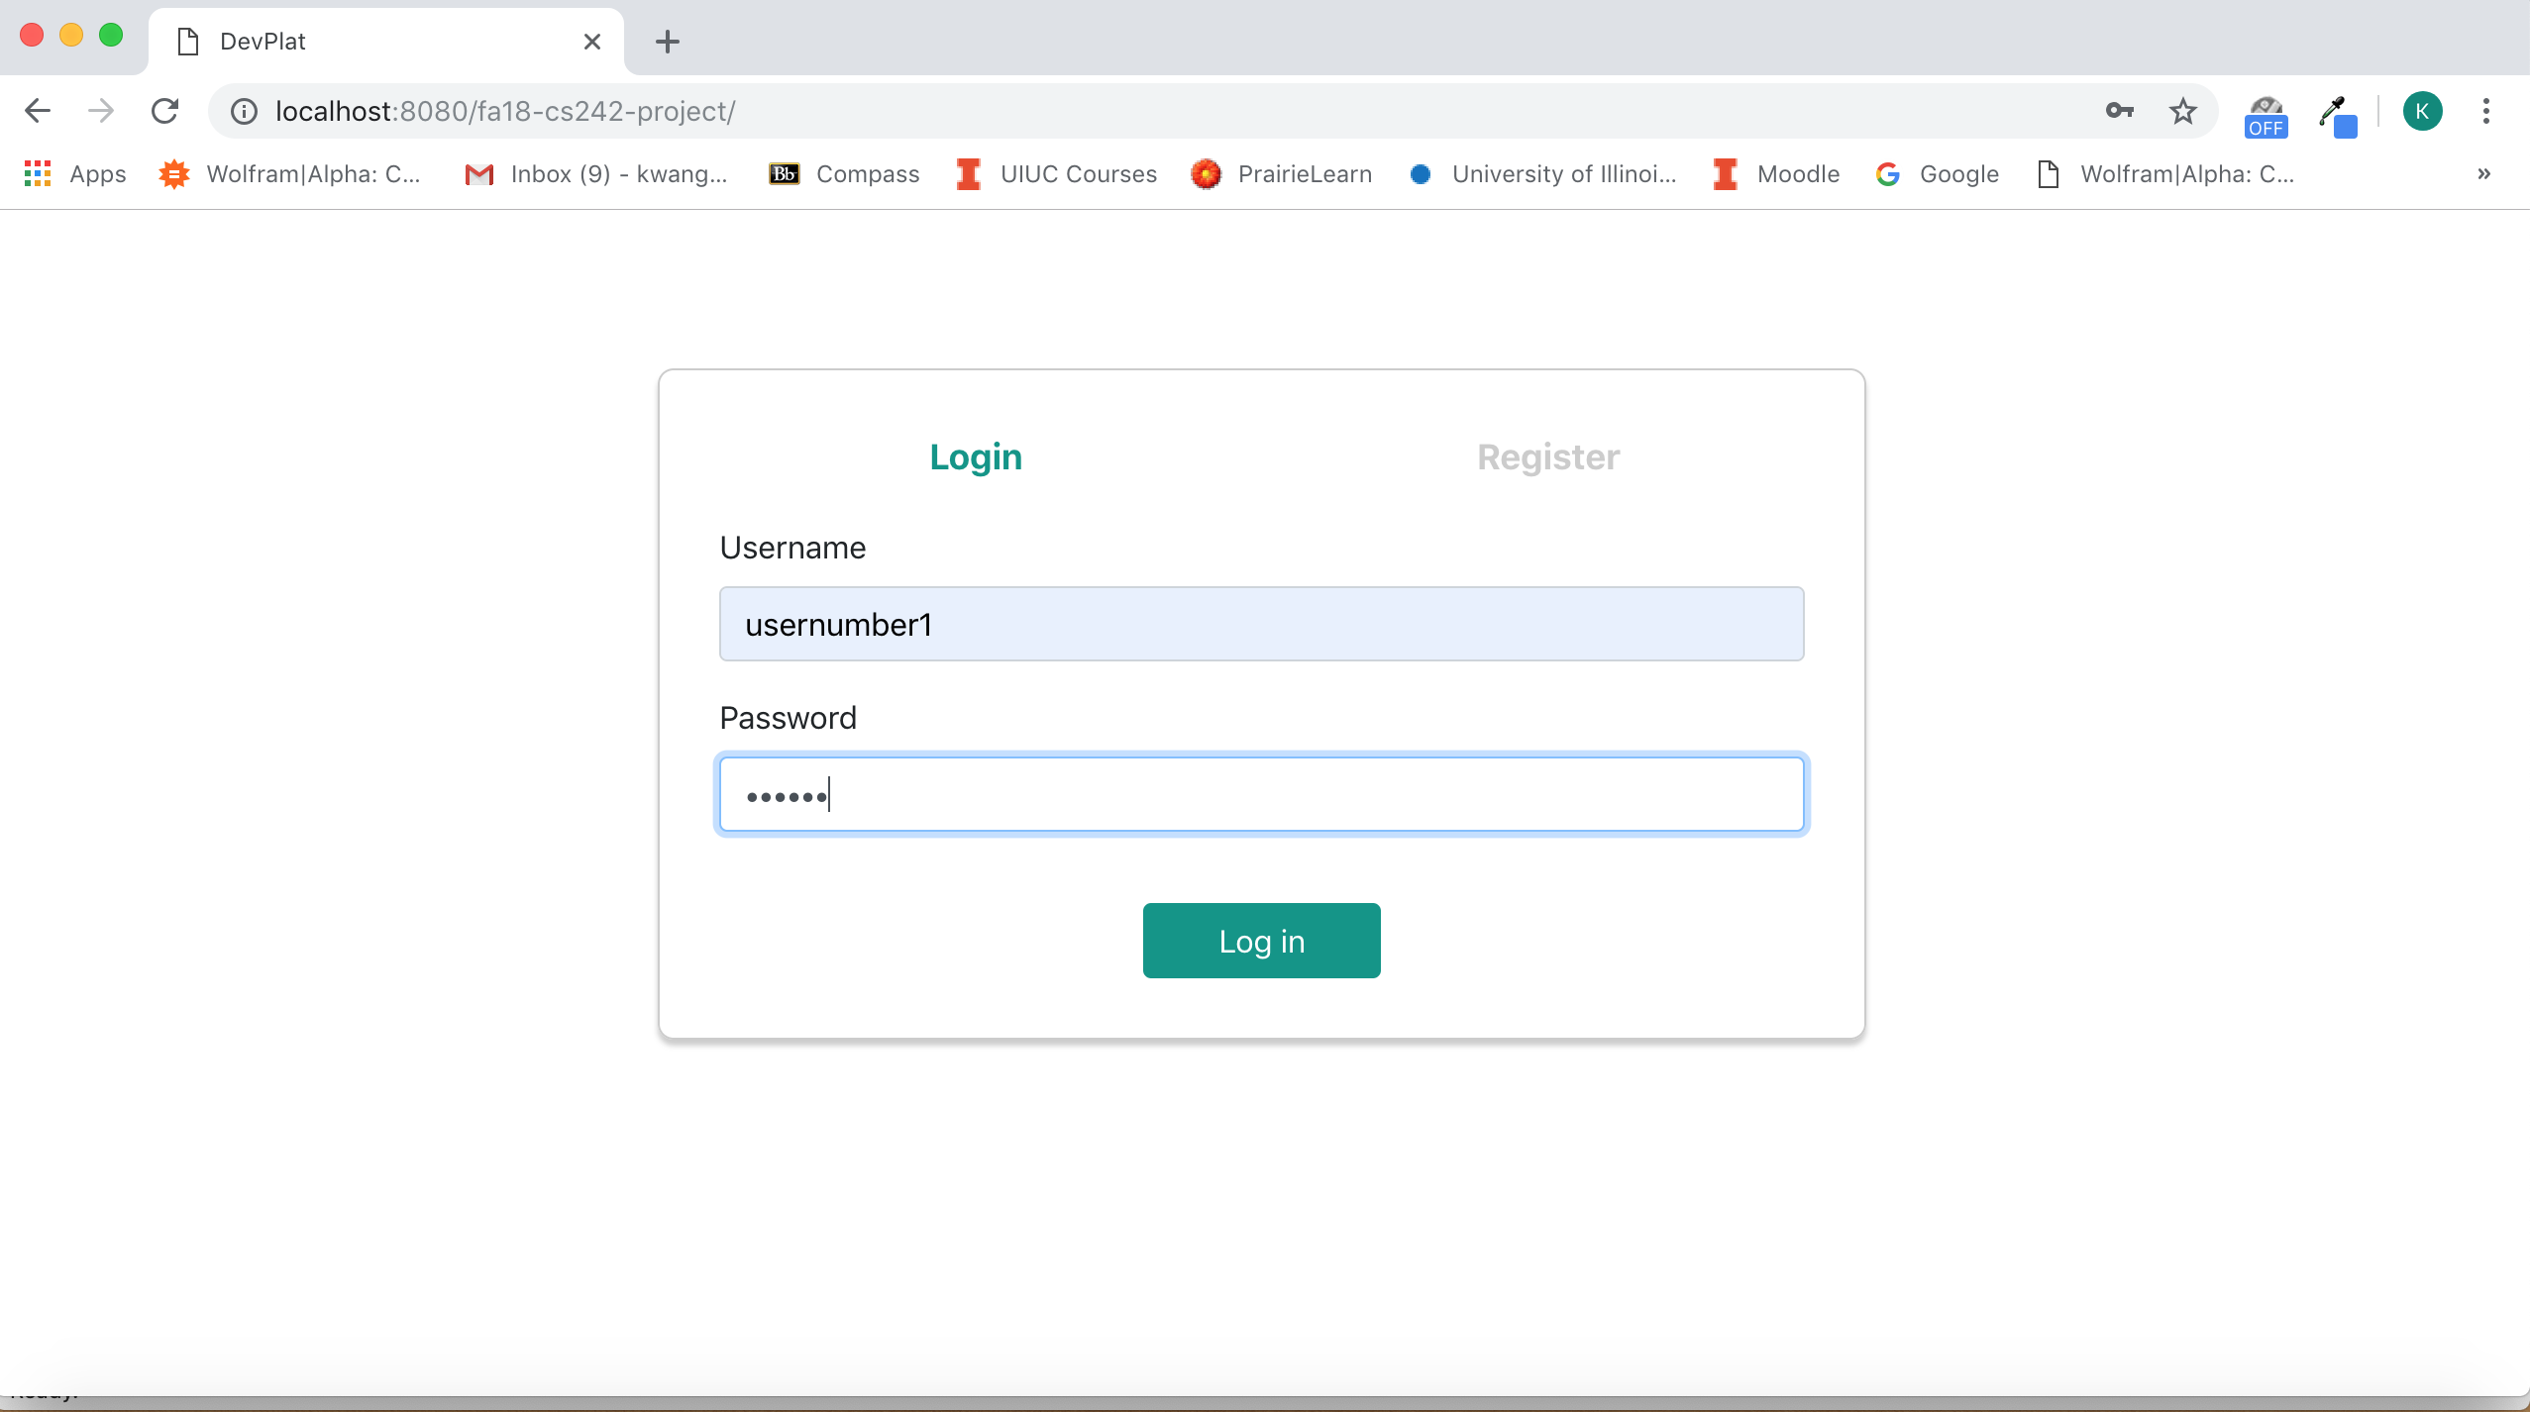

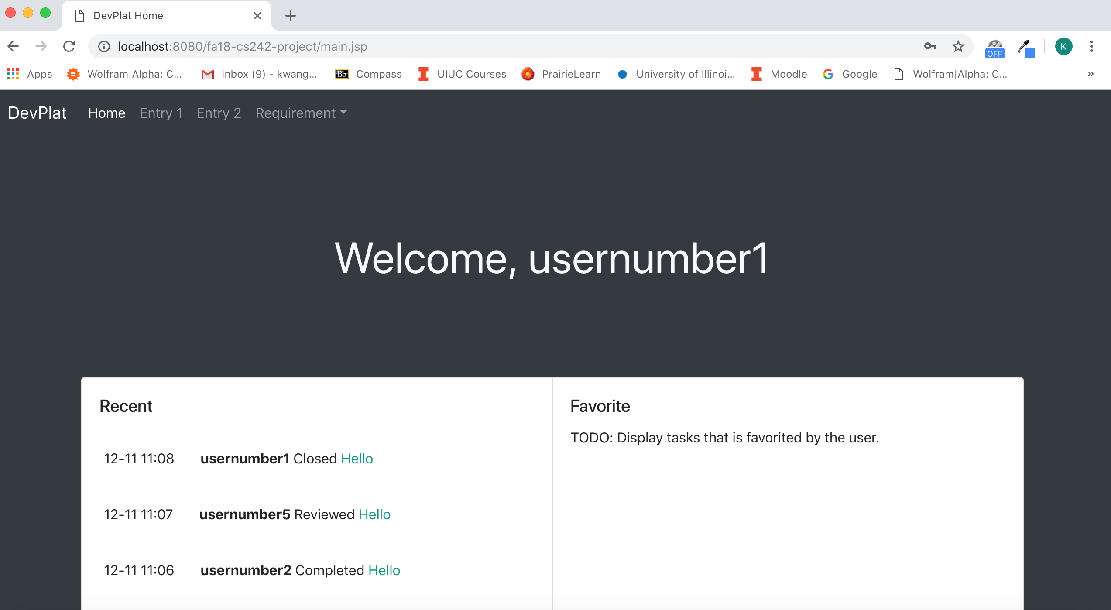

Create a requirement using userbumber1’s account:

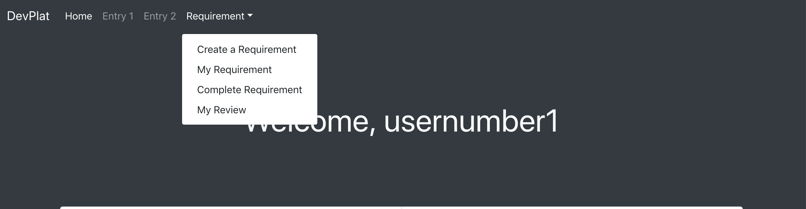

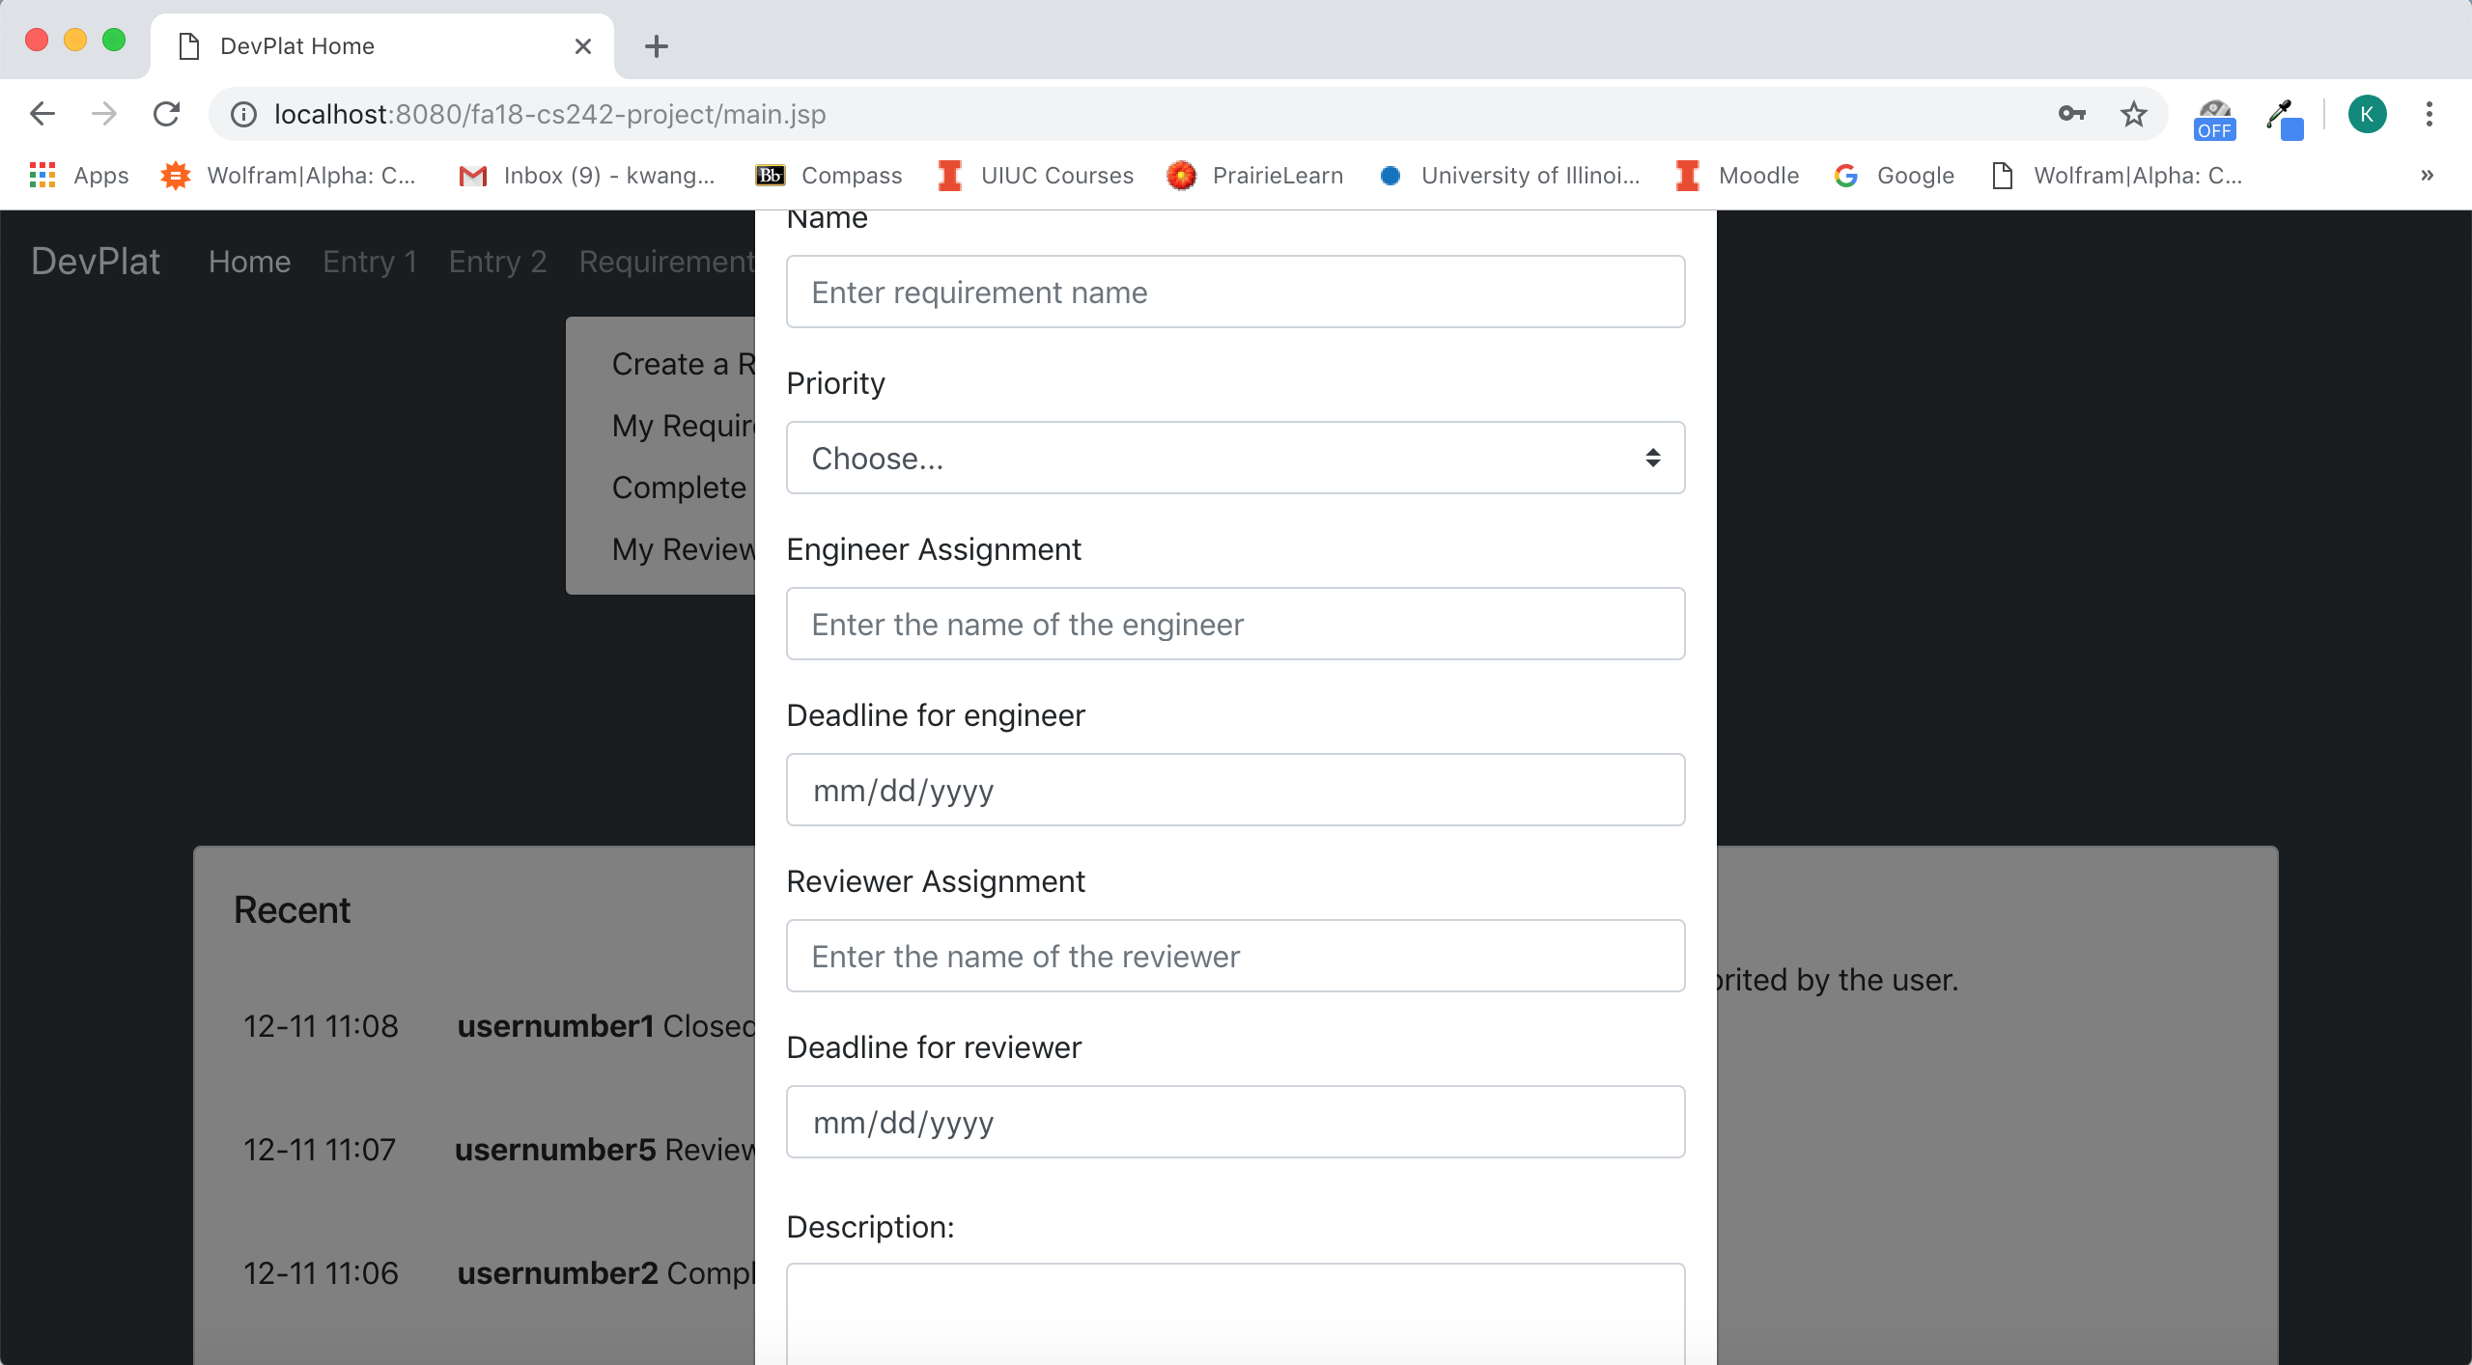

In Engineer Assignment, type “usernumber2” and in Reviewer Assignment, type “usernumber5”. The browser will automatically redirect to My Requirement page after submitting the form.

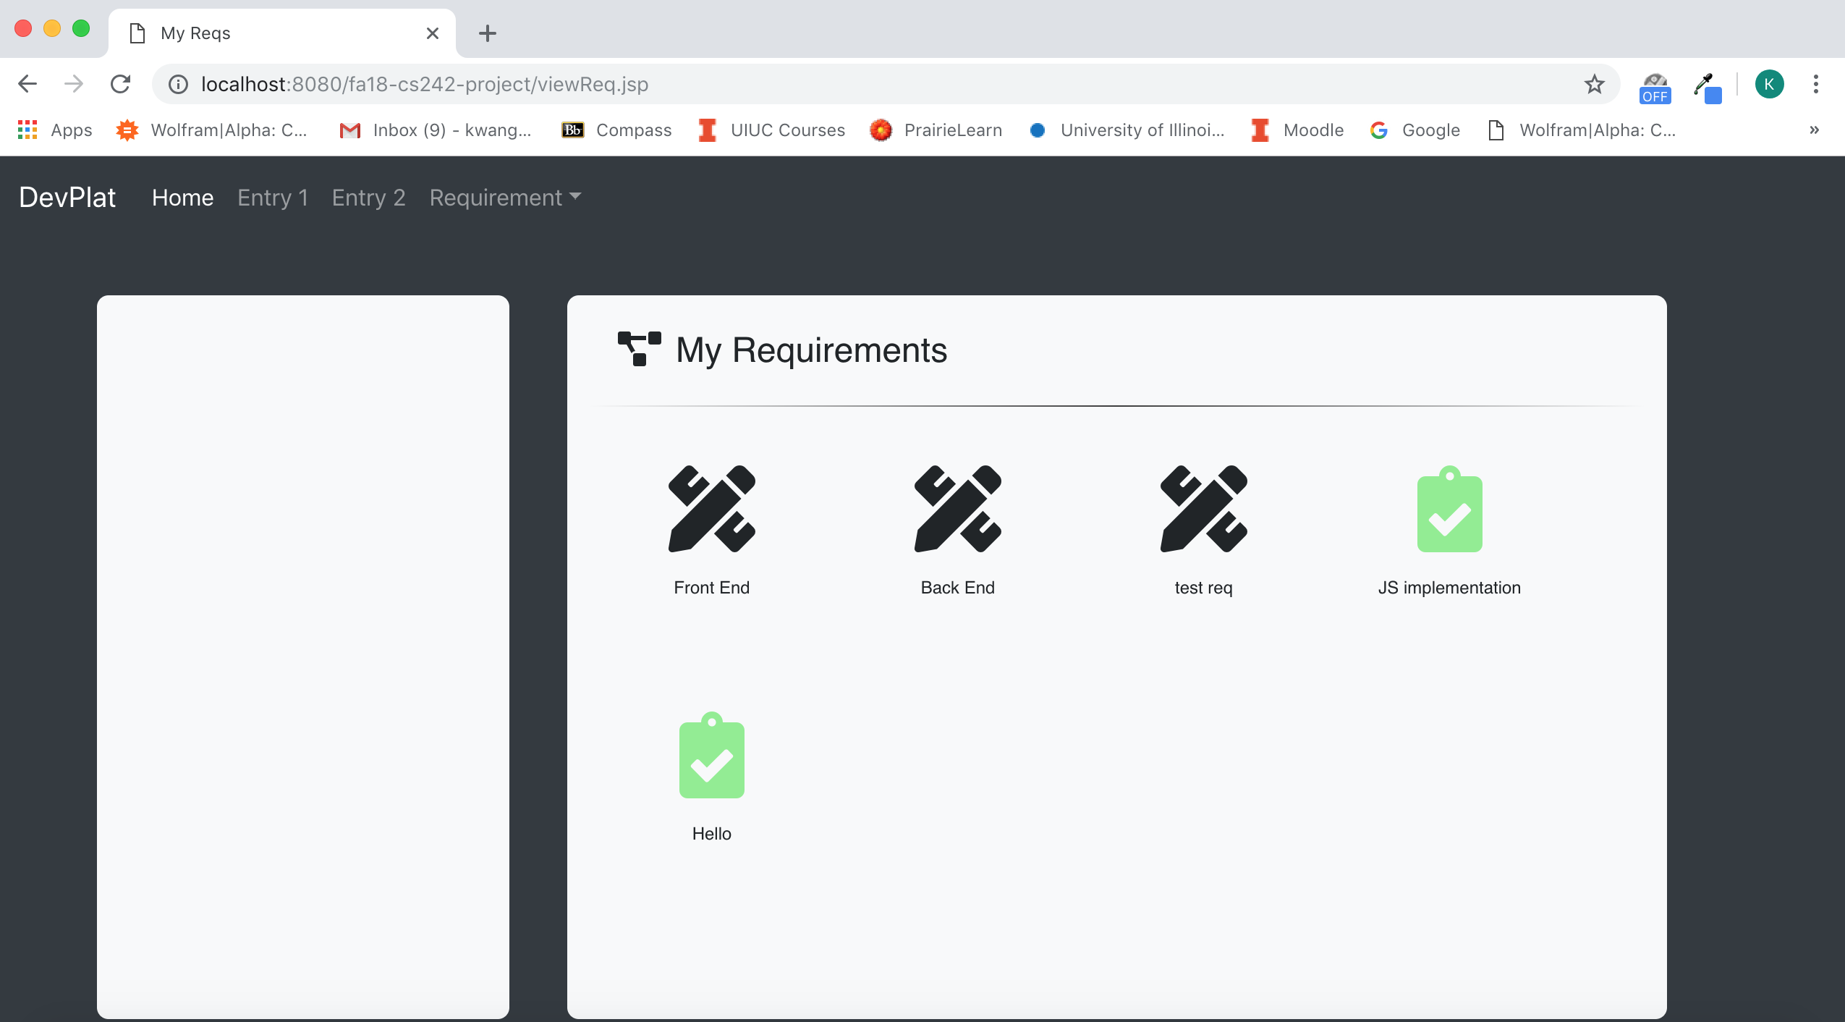

Click Home at the top left corner, make sure the activity is logged:

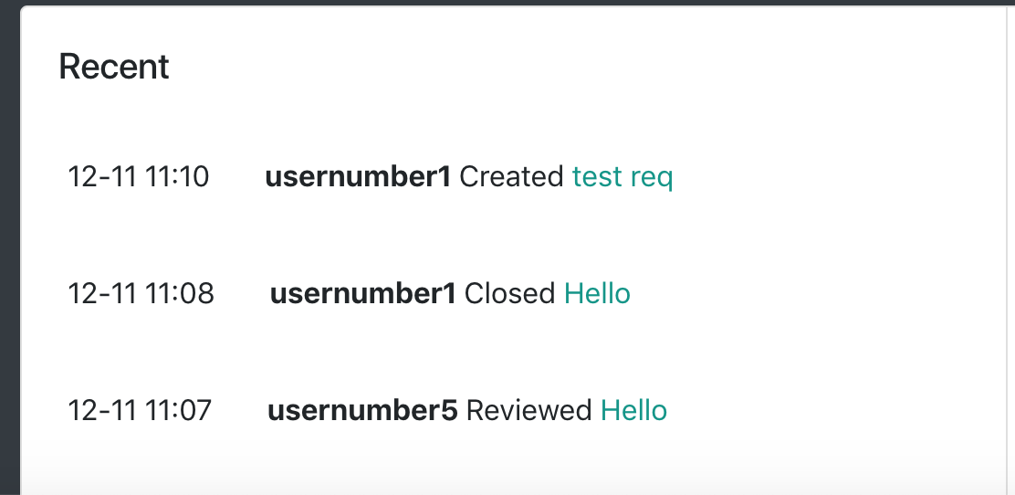

Log out and log in using “usernumber2” and “123456”:

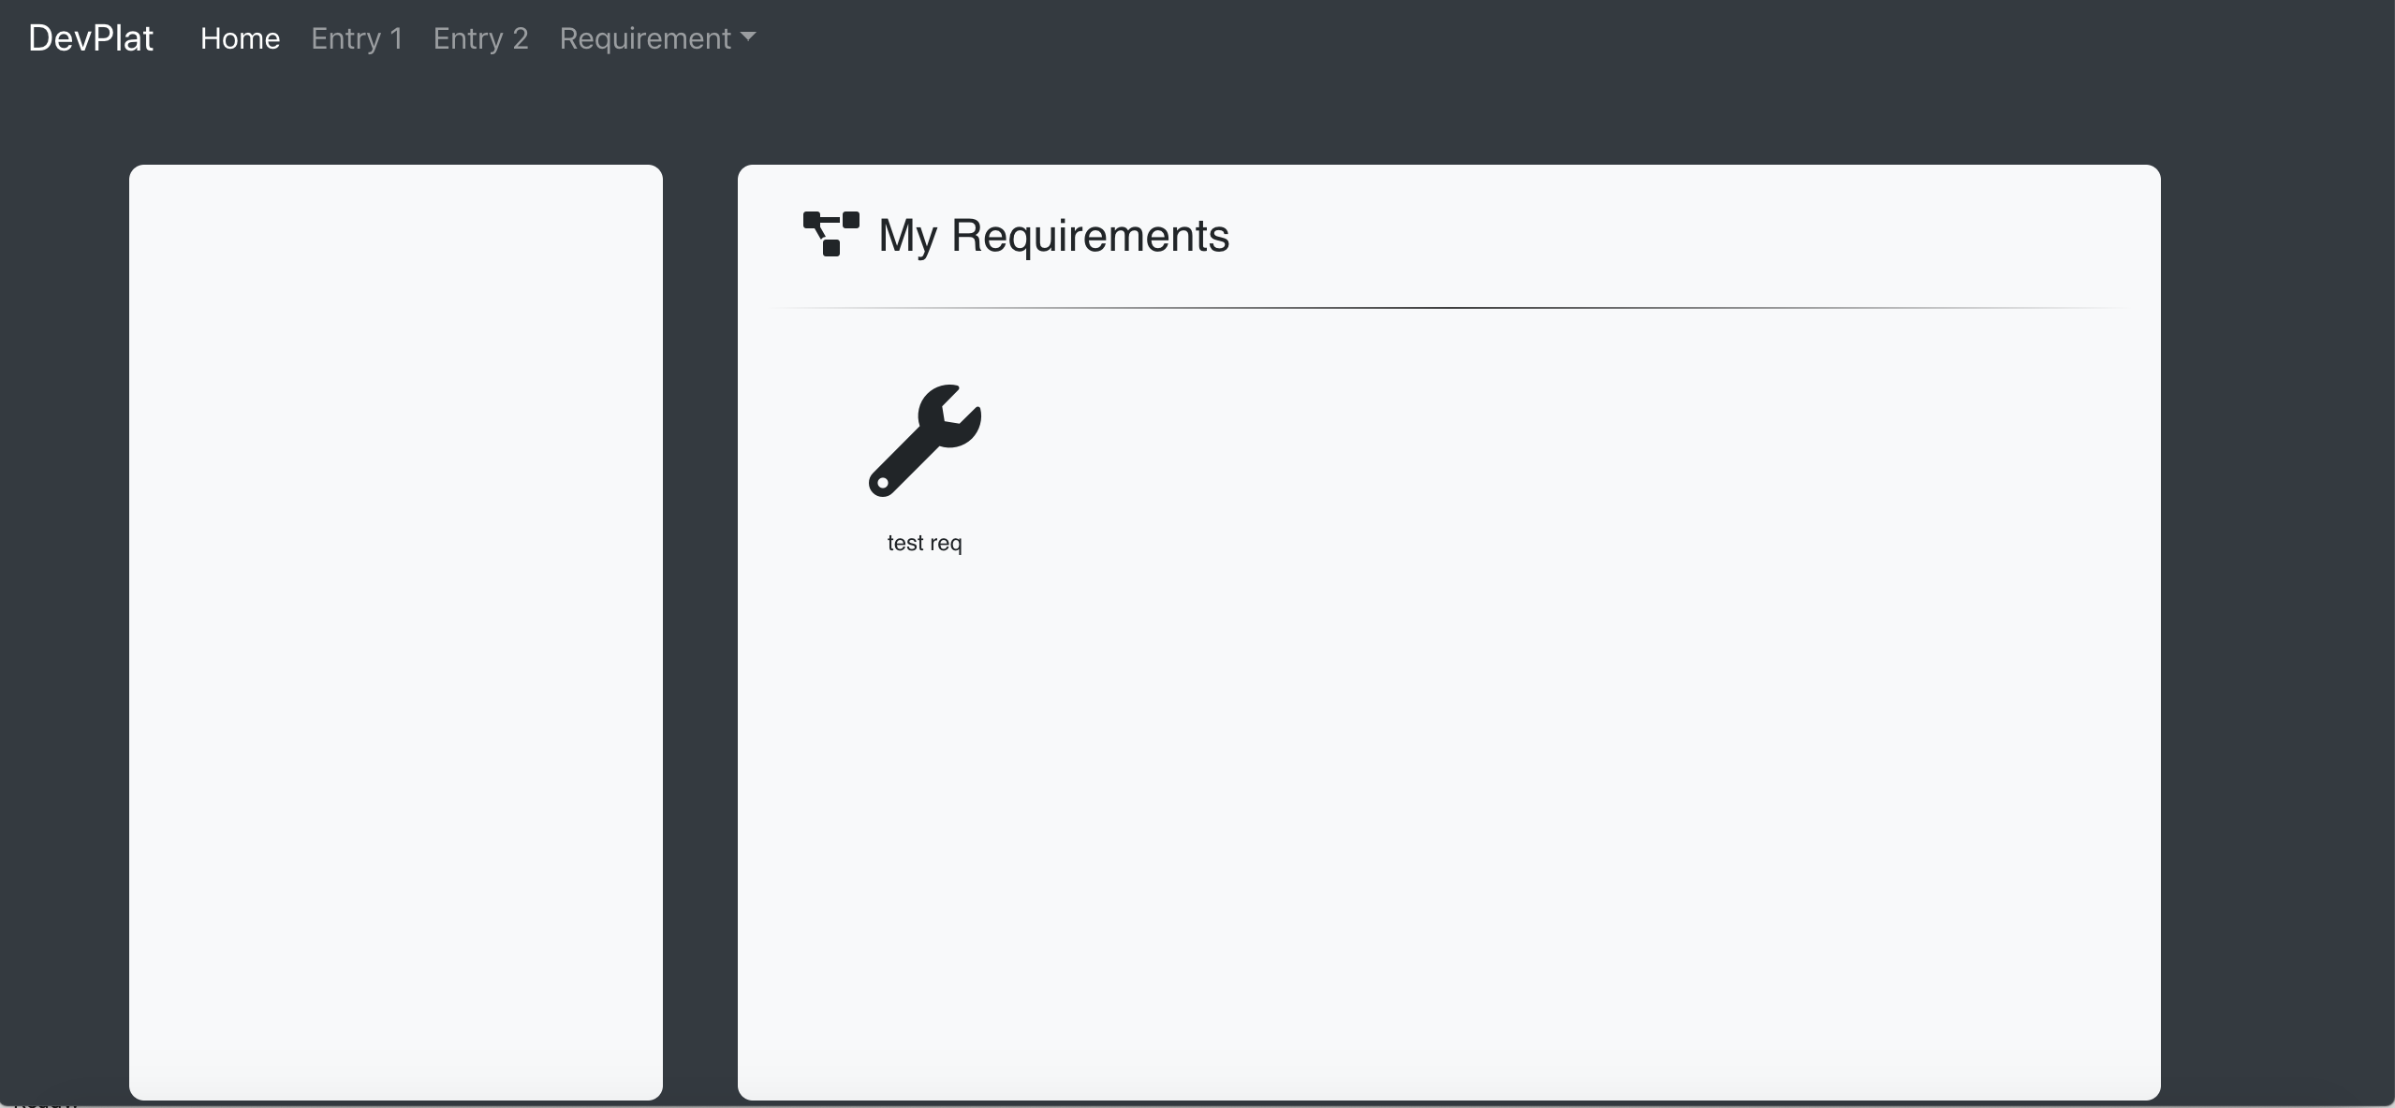

Complete the requirement:

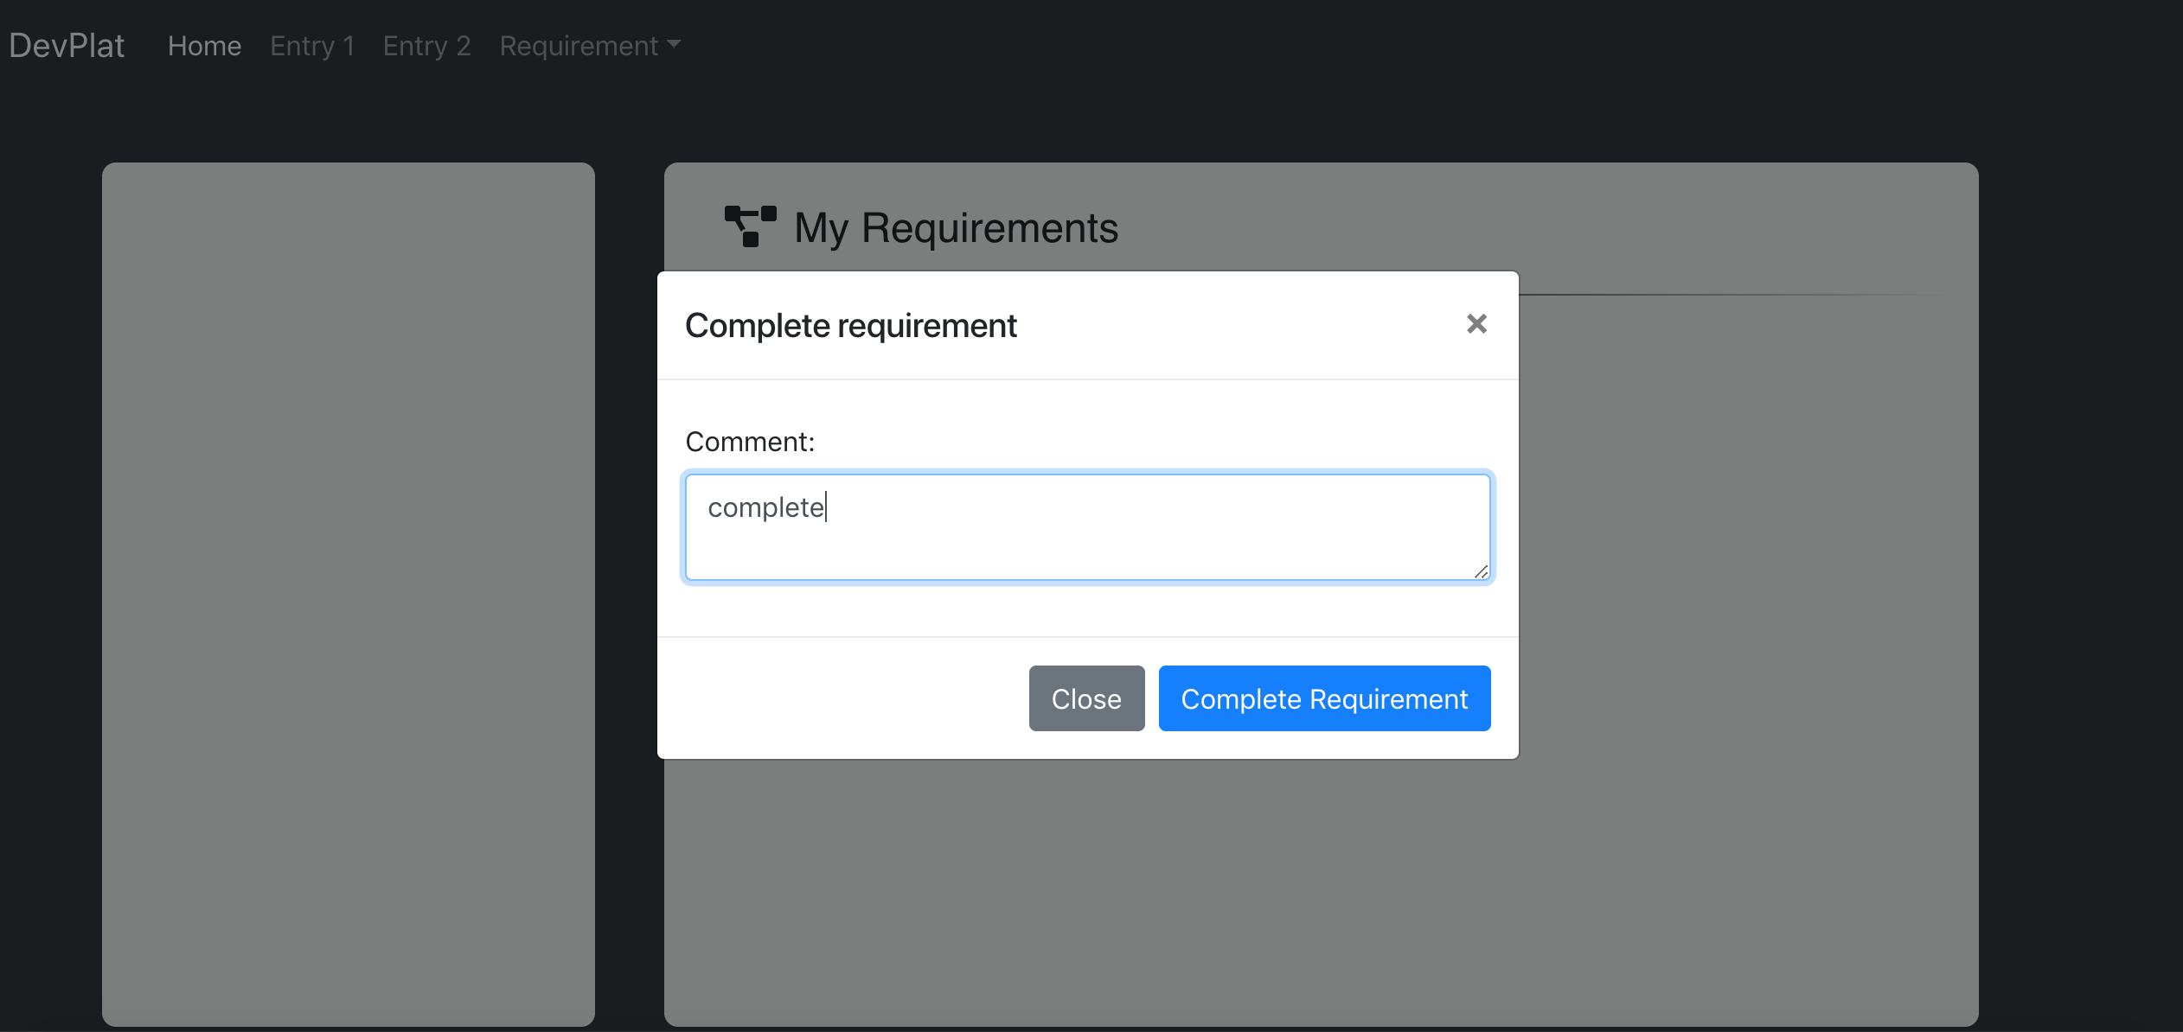

Go to usernumber5’s account:

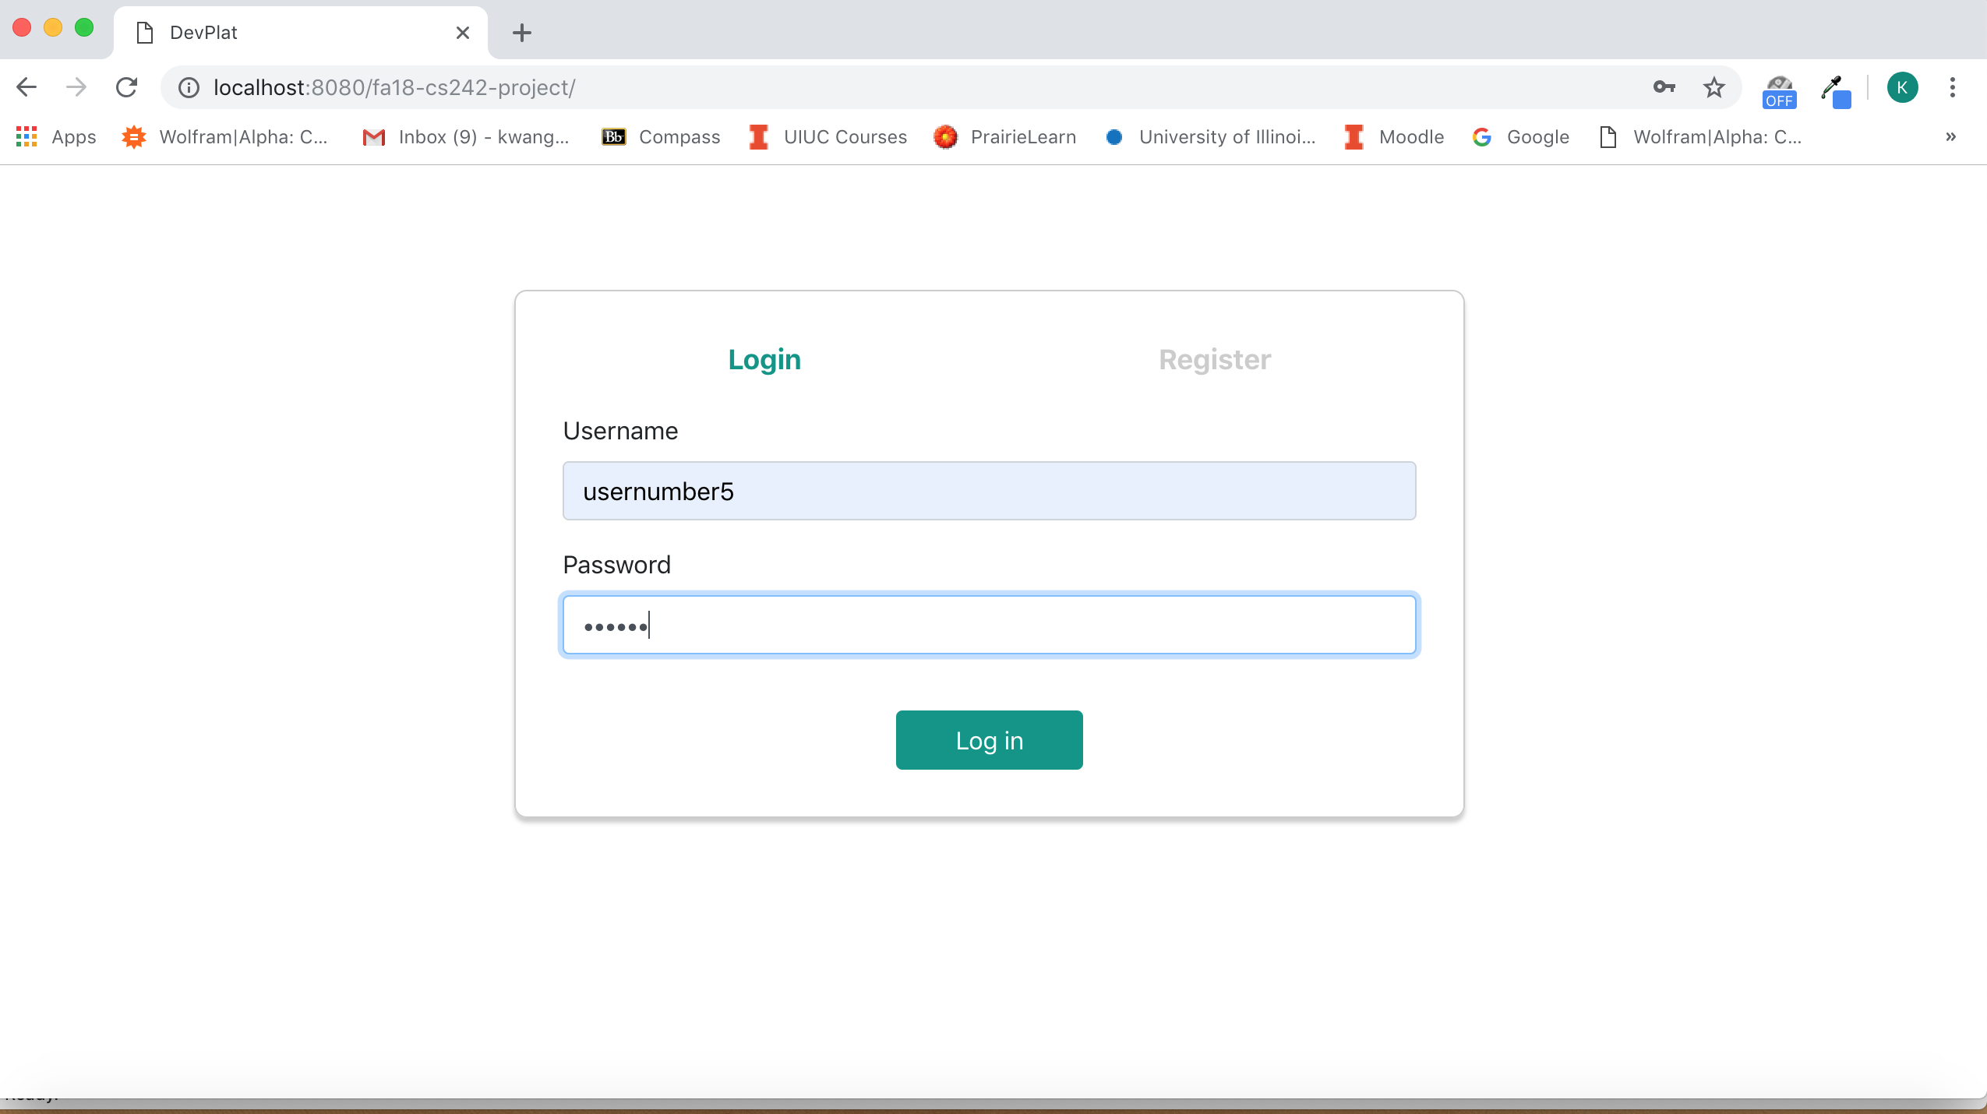

Make sure the logging looks like this

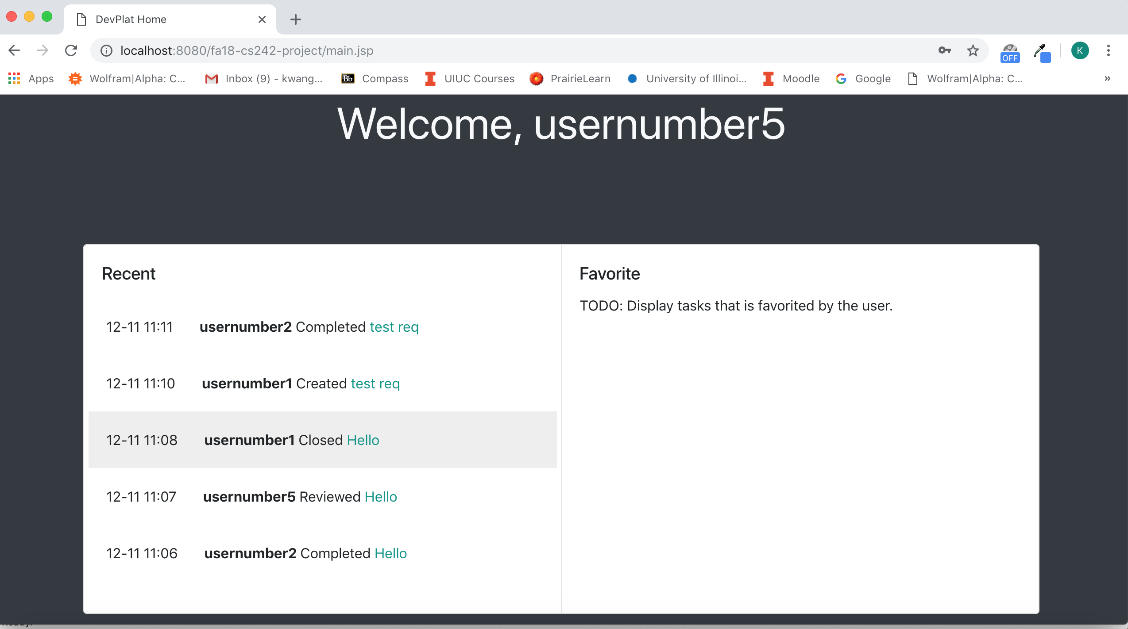

Finish the review:

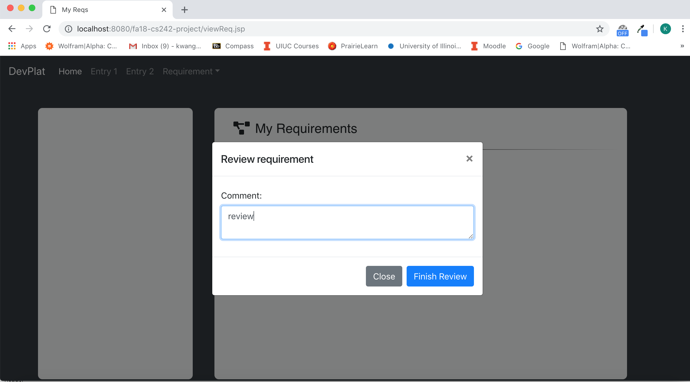

Make sure the review activity is logged.

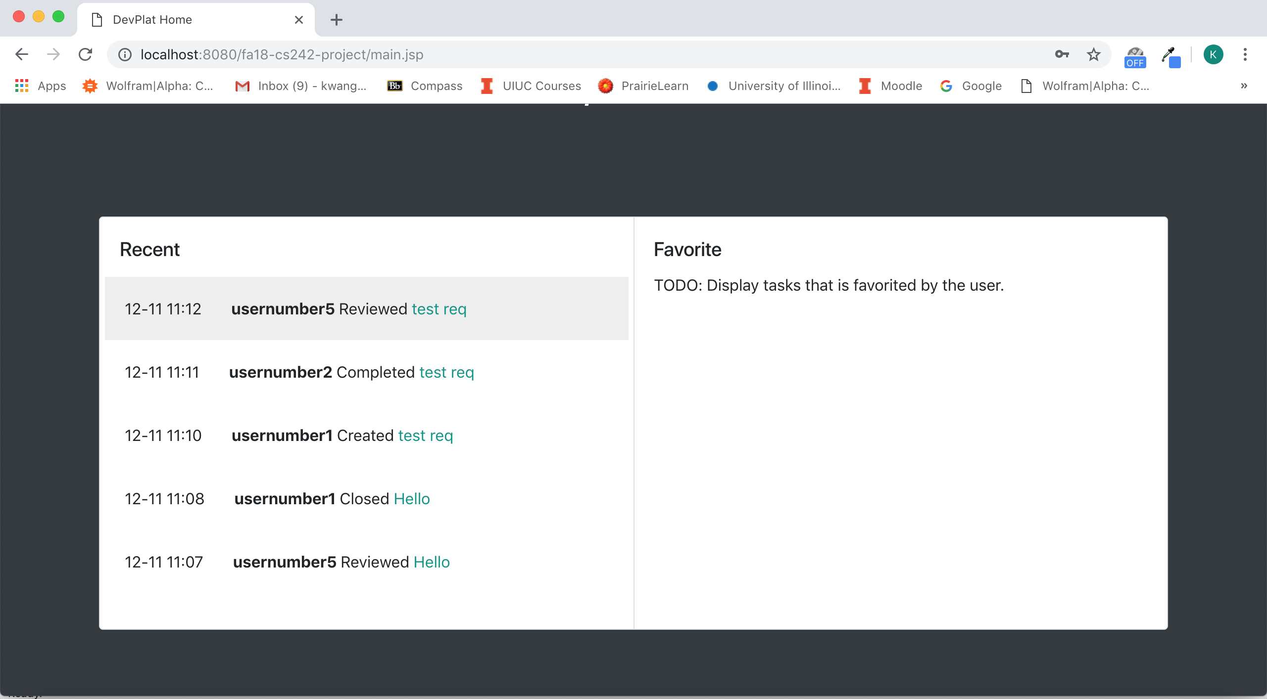

Go back to usernumber1. The requirement should have a different icon and toolbar.

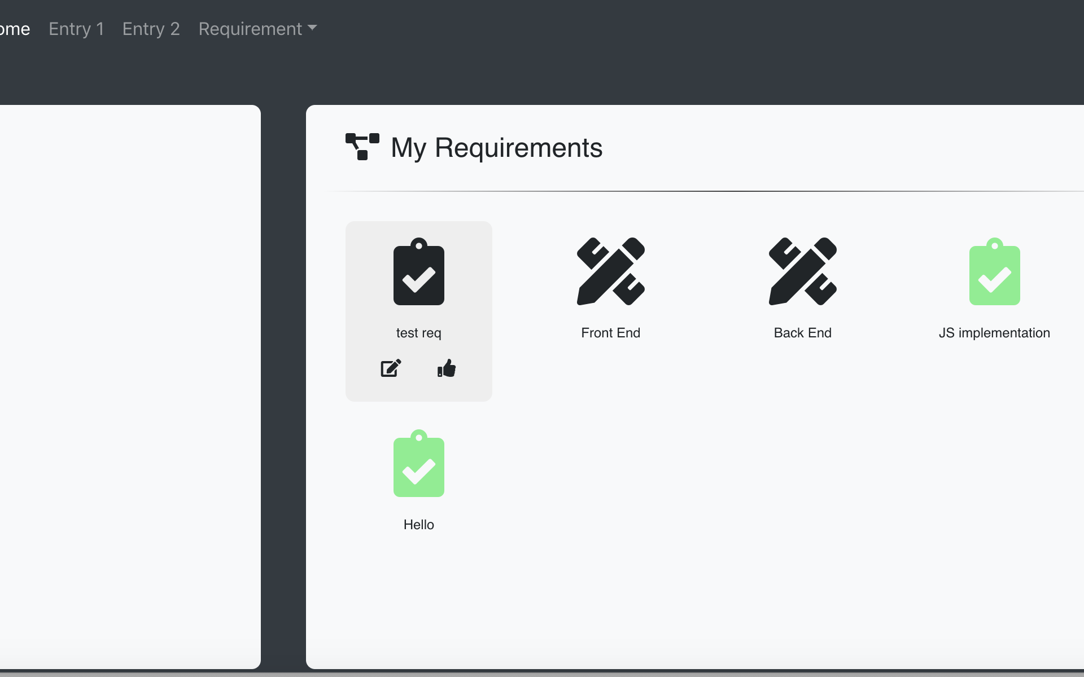

Close it using the thumb up button, and the icon should become green.

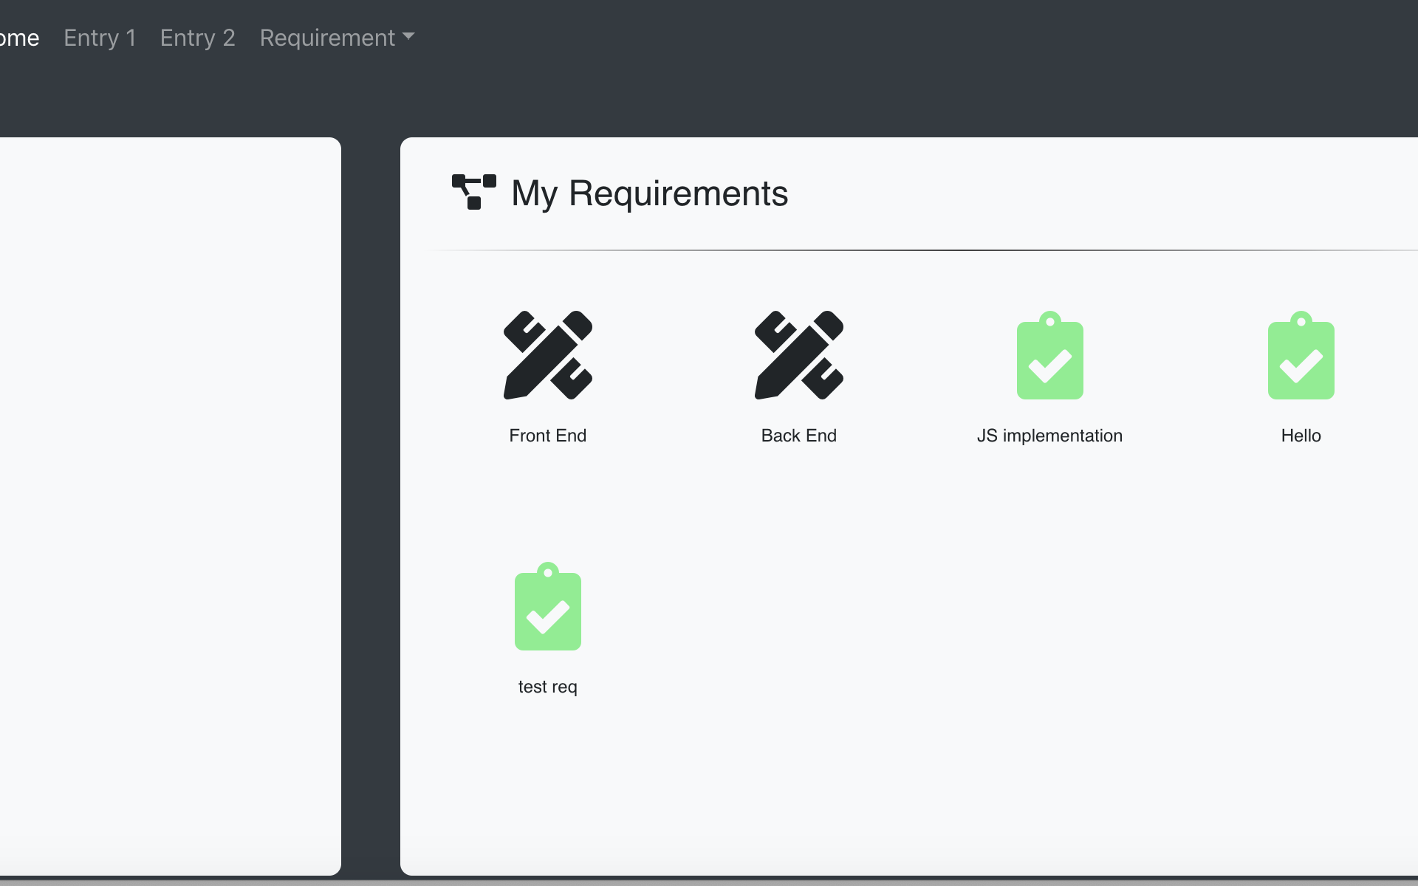

Make sure the close activity is logged:

